

1. name="Productive"
2. echo "Hello, World!"



1. touch file.txt



1. ls -a



1. rm file.txt

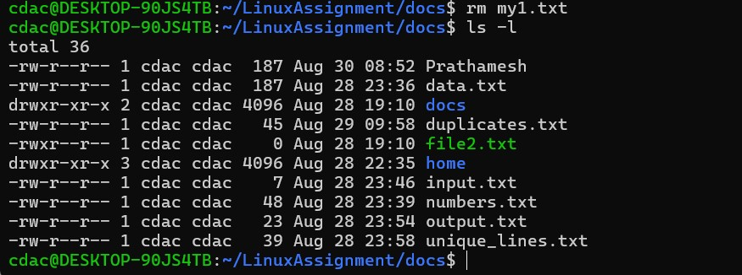

1. cp file1.txt file2.txt



1. mv file.txt /path/to/directory/

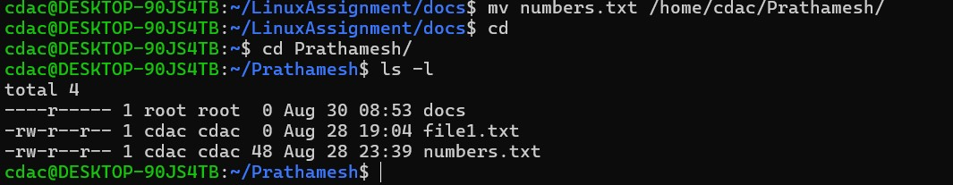

1. chmod 755 script.sh

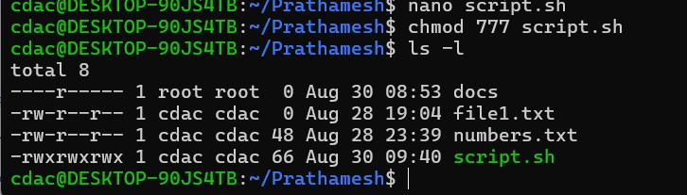

1. grep "pattern" file.txt



1. kill PID



1. mkdir mydir && cd mydir && touch file.txt && echo "Hello, World!" > file.txt && cat file.txt



1. ls -l | grep ".txt"





1. cat file1.txt file2.txt | sort | uniq
2. ls -l | grep "^d"



1. grep -r "pattern" /path/to/directory/



1. cat file1.txt file2.txt | sort | uniq –d



1. cat file1.txt file2.txt | sort | uniq –d

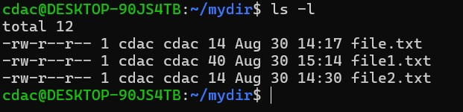

1. cp -r source_directory destination_directory

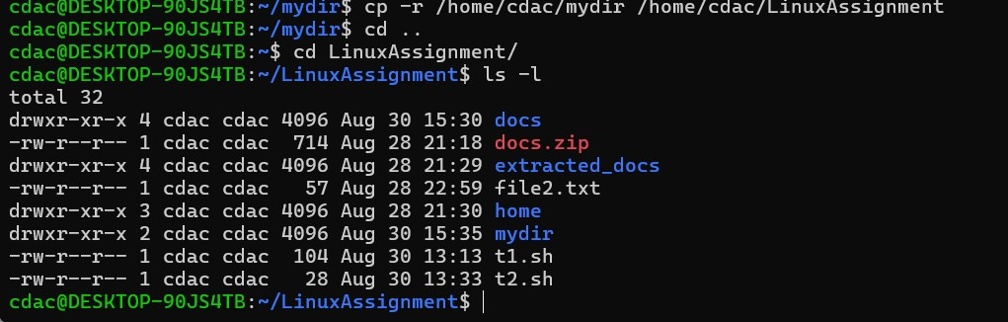

1. find /path/to/search -name "*.txt"

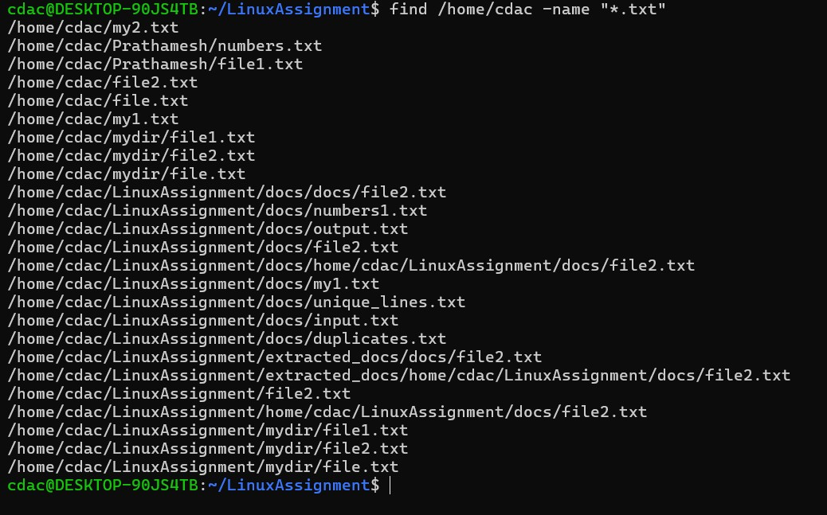

1. chmod u+x file.txt

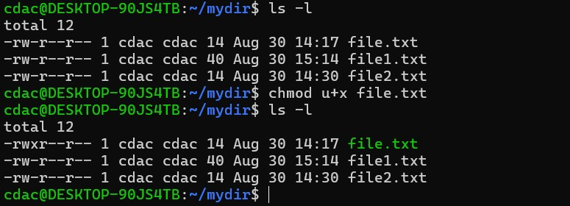

1. echo $PATH

